Polyrepo vs Monorepo

Polyrepo
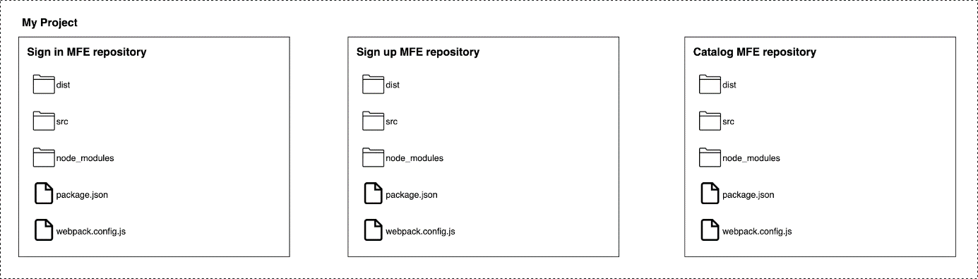

Figure 4-2. 2 Polyrepo example where we split the projects among multiple repositories
The opposite of a monorepo strategy is the polyrepo (figure 7.2), or multi-repo, where every single application lives in its own repository.
Some benefits of a polyrepo strategies are:
- Different branching strategy per project: With monorepo, we should use trunk-based development, but with a polyrepo strategy we can use the right-branching strategy for the project we are working on.
Imagine, for instance, that we have a legacy project with a different release cadence than other projects that are in continuous deployment. With a polyrepo strategy, we can use git flow in just that project, providing a branching strategy specific for that context.
- No risk of blocking other teams: Another benefit of working with a polyrepo is that the blasting radius of our changes is strictly confined to our project. There isn’t any possibility of breaking other teams’ projects or negatively affecting them because they live in another repository.
- Encourages thinking about contracts: In a polyrepo environment, the communication across projects has to be defined via APIs. This forces every team to identify the contracts between producers and consumers and to create governance for managing future releases and breaking changes.
- Fine-grained access control: Large organizations are likely to work with contractors who should see only the repositories they are responsible for or to have a security strategy in place where only certain departments can see and work on a specific area of the codebase.
Polyrepo is the perfect strategy for achieving that fine-grained access control on different codebases, introducing roles, and identifying the level of access needed for every team or department.
- Less upfront and long-term investment in tooling: With a polyrepo strategy we can easily use any tool available out there. Usually, the repositories are not expanding at the same rate as monorepo repositories because fewer developers are committing to the codebase.
That means your investment upfront and in maintaining the build of a polyrepo environment is far less, especially when you automate your CI/CD pipeline using infrastructure as code or command-line scripts that can be reused across different teams.
Polyrepo also has some caveats:
- Difficulties with project discoverability: By its nature, polyrepo makes it more difficult to discover other projects because every project is hosted in its own repository. Creating a solid naming convention that allows every developer to discover other projects easily can help mitigate this issue.
Unquestionably, however, polyrepo can make it difficult for new employees or for developers who are comparing different approaches to find other projects suitable for their researches.
- Code duplication: Another disadvantage of polyrepo is code duplication. For example, a team creates a library that will be used by other teams for standardizing certain approaches, but the tech department is not aware of that library.
Often, there are libraries that should be used across several micro-frontends, like logging or observability integration, but a polyrepo strategy doesn’t facilitate code-sharing if there isn’t good governance in place. It’s helpful, then, to identify the common aspects that may be beneficial for every team and coordinate the codesharing effort across teams. Architects and tech leaders are in the perfect position to do this, since they work with multiple teams and have a high-level picture of how the system works and what it requires.
- Naming convention: In polyrepo environments, I’ve often seen a proliferation of names without any specific convention; this quickly compounds the issue of tracking what is available and where.
Regulating a naming convention for every repository is critical in a polyrepo system because working with micro-frontends, and maybe with microservice as well, could result in a huge amount of repositories inside our version of control.
- Best practice maintenance: In a monorepo environment, we have just one repository to maintain and control. In a polyrepo environment, it may take a while before every repository is in line with a newly defined best practice.
Again, communication and process may mitigate this problem, but polyrepo requires you think this through upfront because finding out these problems during development will slow down your teams’ throughput.
Polyrepo is definitely a viable option for micro-frontends, though we risk having a proliferation of repositories. This complexity should be handled with clear and strong governance around naming conventions, repository discoverability, and processes.
Micro-frontends projects with a vertical split have far fewer issues using polyrepo than those with a horizontal split, where our application is composed of tens, if not hundreds, of different parts.
In the context of micro-frontends, polyrepo also makes it possible to use different approaches from a legacy project. In fact, we may introduce new tools or libraries just for the micro-frontends approach, while keeping the same one for the legacy project without the need of polluting the best practices in place in the legacy platform.
This flexibility has to be gauged against potential communication overhead and governance that has to be defined inside the organization; therefore if you decide to use polyrepo, be aware of where your initial investment should be: communication flows across teams and governance.

Figure 4-1. 1 Monorepo example where all the projects live inside the same repository

Monorepo
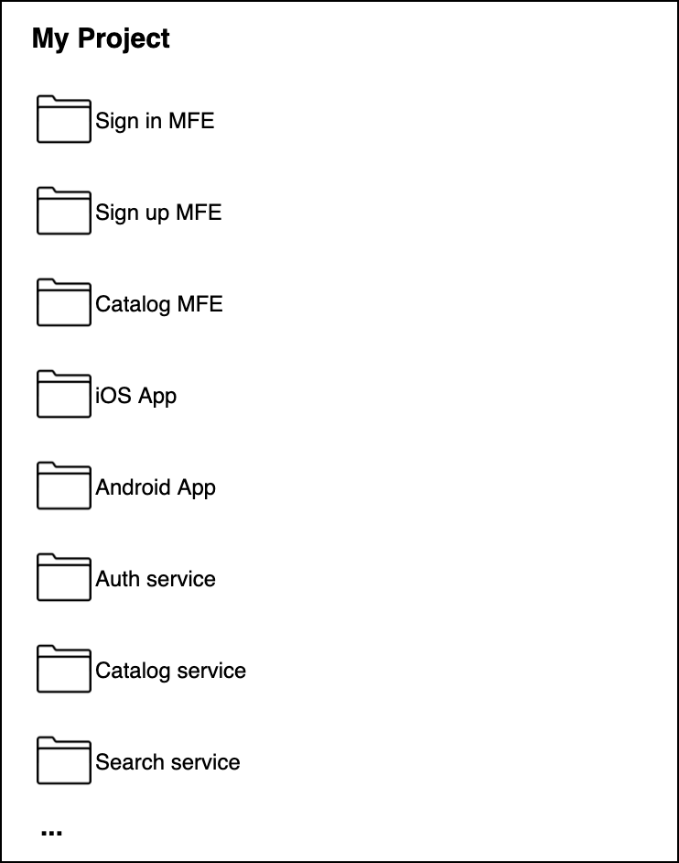

Figure 4-1. 1 Monorepo example where all the projects live inside the same repository
Monorepo (figure 7.1) is based on the concept that all the teams are using the same repository, therefore all the projects are hosted together.
The main advantages of using monorepo are:
- Code reusability: Sharing libraries becomes very natural with this approach. Because all of a project’s codebase lives in the same repository, we can smoothly create a new project, abstracting some code and making it available for all the projects that can benefit from it.
- Easy collaboration across teams: Because the discoverability is completely frictionless, teams can contribute across projects. Having all the projects in the same place makes it easy to review a project’s codebase and understand the functionality of another project. This approach facilitates communication with the team responsible for the maintenance in order to improve or simply change the implementation pointing on a specific class or line of code without kicking off an abstract discussion.
- Cohesive codebase with less technical debt: Working with monorepo encourages every team to be up-to-date with the latest dependencies versions, specifically APIs but generally with the latest solutions developed by other teams, too.
This would mean that our project may be broken and would require some refactoring when there is a breaking change, for instance. Monorepo forces us to continually refactor our codebase, improving the code quality, and reducing our tech debt.
- Simplified dependencies management: With monorepo, all the dependencies used by several projects are centralized, so we don’t need to download them every time for all our projects. And when we want to upgrade to the next major release, all the teams using a specific library will have to work together to update their codebase, reducing the technical debt that in other cases a team may accumulate.
Updating a library may cost a bit of coordination overhead, especially when you work with distributed teams or large organizations.
- Large-scale code refactoring: Monorepo is very useful for large-scale code refactoring. Because all the projects are in the same repository, refactoring them at the same time is trivial. Teams will need to coordinate or work with technical leaders, who have a strong high-level picture of the entire codebase and are responsible for refactoring or coordinating the refactor across multiple projects.
- Easier onboarding for new hires: With monorepo a new employee can find code samples from other repositories very quickly.
Additionally, a developer can find inspiration from other approaches and quickly shape them inside the codebase.
Despite the undoubted benefits, embracing monorepo also brings some challenges:
- Constant investment in automation tools: Monorepo requires a constant, critical investment in automation tools, especially for large organizations.
There are plenty of open-source tools available but not all are suitable for monorepo, particularly after some time on the same project, when the monorepo starts to grow exponentially.
- Many large organizations must constantly invest in improving their automation tools for monorepo to avoid their entire workforce being slowed down by intermittent commitment on improving the automation pipelines and reducing the time of this feedback loop for the developers.
- Scaling tools when the codebase increases: Another important challenge is that automation pipelines must scale alongside the codebase.
Many whitepapers from Google, Facebook and Twitter claim that after a certain threshold, the investment in having a performant automation pipeline increases until the organization has several teams working exclusively on it.
Unsurprisingly, every company aforementioned has built its own version of build tools and released it as open-source, considering the unique challenges they face with thousands of developers working in the same repository.
- Projects are coupled together: Given that all the projects are easy to access and, more often than not, they are sharing libraries and dependencies, we risk having tightly coupled projects that can exist only when they are deployed together. We may, therefore, not be able to share our micro-frontends across multiple projects for different customers where the codebase lives in different monorepo. This is a key consideration to think before embracing the monorepo approach with micro-frontends.
- Trunk-based development: Trunk-based development is the only option that makes sense with monorepo. This branching strategy is based on the assumption that all the developers commit to the same branch, called a trunk. Considering that all the projects live inside the same repository, the trunk main branch may have thousands of commits per day, so it’s essential to commit often with small commits instead of developing an entire feature per day before merging. This technique should force developers to commit smaller chunks of code, avoiding the “merge hell” of other branching strategies.
- Although I am a huge fan of trunk-based development, it requires discipline and maturity across the entire organization to achieve good results.
- Disciplined developers: We must have disciplined developers in order to maintain the codebase in a good state.
When tens, or even hundreds, of developers are working in the same repository, the git history, along with the codebase, could become messy very quickly.
Unfortunately, it’s almost impossible to have senior developers inside all the teams, and that lack of knowledge or discipline could compromise the repository quality and extend the blast radio from one project inside the monorepo to many, if not all, of them.
Using monorepo for micro-frontends is definitely an option, and tools like Lerna help with managing multiple projects inside the same repository. In fact, Lerna can install and hoist, if needed, all the dependencies across packages together and publish a package when a new version is ready to be released. However, we must understand that one of the main monorepo strengths is its code-sharing capability. It requires a significant commitment to maintain the quality of the codebase, and we must be careful to avoid coupling too many of our micro-frontends because we risk losing their nature of independent deployable artifacts.
Git has started to invest in reducing the operations time when a user invokes commands like git history or git status in large repositories. And as monorepo has become more popular, Git has been actively working on delivering additional functionalities for filtering what a user wants to clone into their machine without needing to clone the entire git history and all the projects folders.
Obviously, these enhancements will be beneficial for our CI/CD, as well, where we can overcome one of the main challenges of embracing a monorepo strategy.

Sparse-checkout
In Q1 2020, Git introduced the sparse-checkout command (Git >2.25) for cloning only part of a repository instead of all the files and history of a repository.
Reducing the amount of data to clone for running fast automation pipelines would solve one of the main challenges of embracing monorepo.
We need to remember that using monorepo would mean investing in our tools, evangelizing and building discipline across our teams, and finally accepting a constant investment in improving the codebase. If these characteristics suit your organization, monorepo would likely allow you to successfully support your projects.
Many companies are using monorepo, specifically large organizations like Google and Facebook, where the investment in maintaining this paradigm is totally sustainable.
One of the most famous papers on monorepo was written by Google’s Rachel Potvin and Josh Levenberg. In their concluding paragraph they write:
“Over the years, as the investment required to continue scaling the centralized repository grew, Google leadership occasionally considered whether it would make sense to move from the monolithic model. Despite the effort required, Google repeatedly chose to stick with the central repository due to its advantages.
“The monolithic model of source code management is not for everyone. It is best suited to organizations like Google, with an open and collaborative culture. It would not work well for organizations where large parts of the codebase are private or hidden between groups.”

